Digital Therapeutics in Rural Maternal Child Health
How to Go from Episodic to Lived Environment Care
The Science of Remote Integrative Psychosocial and Physical Care
Including Underserved and Economically Disadvantaged Communities

Presenter:
- Bob Gold, Clinical Behavioral Technologist (summary BIO on last page)

Presentation Mission:
Being the Health Partner to a consumer throughout their Patient Journey
The mission of this talk is to change the way you personally and professionally believe your organization should approach ​Population Health Management and Care Coordination in vulnerable communities. ​How to go from episodic to relationship care.

Presentation Description:
This educational talk uses real-life use cases and outcomes in rural America on applying a behavioral science and remote system of care for pre-natal and post-partum Medicaid moms and families. The data discussed includes items such as pre-term births, anxiety and depressive disorders, costs of care including ED and inpatient/readmissions, patient activation and satisfaction measures, personal/social challenges, clinical fatigue/joy in practice, and key topics such as adherence to vaccines, wellness appts, safe sleep, crying baby, and others.

Background Rationale
Industry drivers necessitate changing how healthcare systems and providers engage patients relating to the delivery of clinical processes that achieve measurable business and patient outcomes. The science and method on how we engage a consumer is as important to personalized medicine and adherence as the drug itself and its associated clinical protocols.

The changing roles and influence of stakeholders along the care continuum call for a more cross-functional, collaborative customer model. Health delivery practices need to include new blended human and digital care coordination methods that enable quality scalability to more people to maximize health outcomes and reduce costs and burdens.

To achieve any measurable outcomes healthcare delivery must be viewed from the perspective of a PATIENT JOURNEY ​rather than an EPISODIC ENCOUNTER. ​ This talk discusses an evidence-based behavioral engagement science and method using proven cognitive and psychological techniques that foster and build patient activation, confidence, and resiliency to better self-manage by stimulating positive emotional attributes (such as trust, credibility, reciprocity) to motivate in-the-moment actions within their lived environment. ​

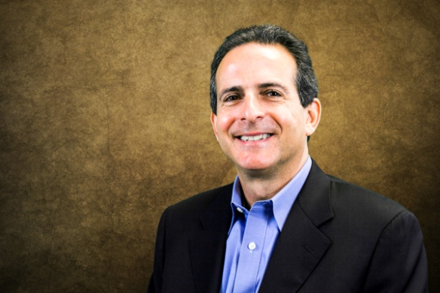
About the Presenter:
Bob Gold, Behavioral Technologist
Bob Gold is one of the world’s leading behavioral technologists with more than 20 years applied research and development in the behavioral and cognitive science of human motivation, activation and resiliency; with a specialty in the human and social factors of precision health and digital therapies leading to increased activation of patients and clinicians in underserved vulnerable communities; both rural and urban.

